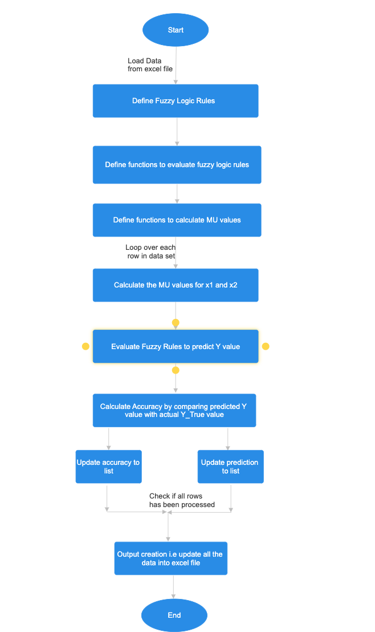

FUZZIFICATION INITIALIZATION
DEFINE MEMBERSHIP FUNCTIONS AND CALUCLATE FOR INPUT VARIABLES
FUZZY INFERENCE SYSTEM
DEFINE FUZZY RULE BANK
DEFINE COMPUTATIONS TO PREDICT Y VALUE
PREDICTIONS AND MODEL ACCURACY
END
OUTPUT CREATION (UPDATE ALL DATA OUTCOMES TO EXCEL)
ADD PREDICTIONS TO LIST
ADD ACCURACY TO LIST
START

- Modules Used In Coding

1. numpy (import numpy as np) :
Numpy is the fundamental library of Python, used to perform scientific computing. It provides highperformance multidimensional arrays and tools to deal with them.
Used for numerical computations and creating arrays (e.g., np.arange for defining fuzzy variable universes).

2. pandas (import pandas as pd):
Pandas is an opensource, BSDlicensed library written in Python Language. Pandas provide highperformance, fast, easytouse data structures, and data analysis tools for manipulating numeric data and time series.
Used for data manipulation and analysis (e.g., reading Excel files, cleaning data, calculating accuracy, and exporting results).

3. skfuzzy (import skfuzzy as fuzz):
ScikitFuzzy is a collection of fuzzy logic algorithms intended for use in the SciPy Stack, written in the Python computing language
Used for fuzzy logic computations, particularly for defining membership functions.

4. skfuzzy.control (import skfuzzy.control as ctrl):
The skfuzzy.control module (imported as ctrl) in the skfuzzy library is used for designing and implementing fuzzy logic control systems. It provides tools to define antecedents, consequents, and fuzzy rules, which are essential for fuzzy inference.

5. pandas.ExcelWriter
A part of pandas, The pandas.ExcelWriter class is used to write multiple DataFrames to an Excel file while maintaining multiple sheets. It allows more control over the Excel output, such as specifying the file format (.xlsx or .xls), adding multiple sheets, and customizing formatting.

